Lotus Notes 9 Social Edition - Tips & Tricks

The following are several Tips & Tricks for understanding Lotus Notes 9 Social Edition as implemented by SpartanNash and making it more user friendly.

- Additional mail options such as high importance and return receipt can be made available as convenient checkboxes, as such:

To make these checkboxes visible:
  - Start a new message
  - Click the Display menu button at the top of the email
  - Click “Additional Mail Options”

Once set, these options will always be available when creating an email.

- Keyboard shortcuts are available in Lotus Notes. To turn on all the keyboard shortcuts, do the following:

  - On the menu bar, go to File Preferences
  - On the right hand menu, go to “Basic Notes Client Configuration”
  - Scroll to the bottom of the “Additional options” box
  - Check “Enable alternate keyboard shortcuts”
  - Click the “OK” button

Here are some important shortcuts:

New Message | Ctrl + M
Send Email | Alt + 1
Reply w/ History but no Attachments | Ctrl + R
Reply to All w/ History but no Attachments | Ctrl + Shift + R
Edit a Document | Ctrl + E
Expand All Sections / Old Emails | Shift + “+”
Collapse All Sections / Old Emails | Shift + “-“
Open Mail | Ctrl + 1
Open Calendar | Ctrl + 2
Open Contacts | Ctrl + 3
Refresh | F9
Undo | Ctrl + Z
Close Current Window | ESC

- To have an email notification box appear in the lower right of the screen when an email comes in:

  - On the menu bar, go to File Preferences
  - On the left hand menu, select Mail Sending and Receiving
  - Under the Alerts Section, select Slide in a summary.
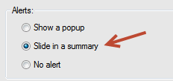

  - Click the “OK” button

The notification box looks like this:

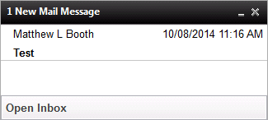

- Changes to email attachments can not be saved on the original email, unlike in Outlook. If you need to make a change to an attachment, save the updated attachment to your Desktop or My Documents folder.

- To edit an existing email in your mailbox:
  - Select the email in question
  - On the menu bar, select Actions Edit
    - Hitting Ctrl + E does the same thing
  - Make your changes
  - Hit “Save and Close”

Please note that the updated email is not resent to the sender or any other recipients

- The All Documents view will show you all the emails in your mailbox, including ones in folders and sent ones. This is a good way to find an email if you can’t remember where it was filed. To access it, click the button in your mailbox. You can sort it the same as any other folder.
- Meeting reminders are not turned on by default in Lotus Notes. To change that and make meeting reminders automatically setup when creating or receiving a meeting invite:

  - On the menu bar, go to File Preferences
  - On the left hand menu, select “Calendar and To Do”
  - Select the tab called “Alarms”
  - Put a check in the “Display alarm notifications” and “Appointments/Meetings” checkboxes
    - You can check any of the other boxes if you want reminders for those as well
  - Set the amount of time you would like for the reminder (30 is the default)
  - Click the “OK” button
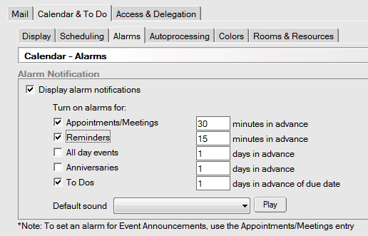

- Archives are no longer needed. SpartanNash has setup email storage and retention rules so that email archives will not be needed.

- To save on email space, the following retention rules have been put in place. If you want to save emails, make sure to put them in a folder:

  - Inbox – Emails in your inbox are deleted if more than 90 days old
  - Trash – Trashed emails are deleted if more than 5 days old
  - Sent – Sent emails are deleted if more than 180 days old
  - Folders – Emails placed in a folder are deleted if more than 5 years old

- To setup a signature to always appear when writing an email:

  - On the menu bar, go to File Preferences
  - On the left hand menu, select “Mail”
  - Select the tab called “Signature”
  - Check the box called “Automatically append a signature to the bottom of my outgoing mail messages”

  - Select the “Rich Text” radio box
  - Write in what you like for your signature in the large text box
    - You can change the font size and color as well as copy in an image
    - It might easier to write up your signature, including an image, in Microsoft Word, and then copy it into the large text box

  - Click the “OK” button

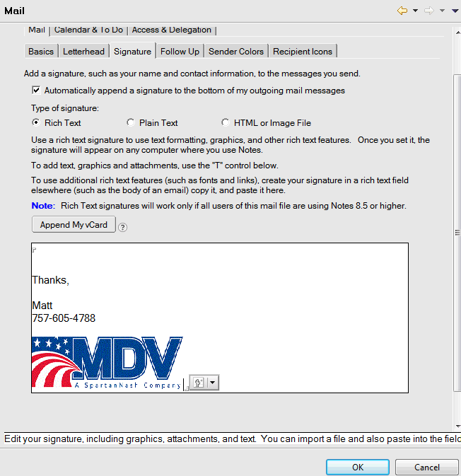
- To attach an existing email in a new email, you need to:

  - Open the existing email
  - Save it as a .eml file somewhere in your Desktop or My Documents folder
  - Start a new message
  - Click the paperclip icon to attach a file
  - Select the saved email from where you saved it

- By default, Lotus Notes does not automatically capitalize the first word of a sentence or perform spell check as you type. To turn these features on:

  - On the menu bar, go to File Preferences
  - On the left hand menu, select “Spell Check”
  - Check the boxes called “Enable Instant Spell checking” and “Capitalize first letter of every sentence”

  - Click the “OK” button

If you would like Lotus Notes to correct common spelling errors automatically, click the “Correct common typing errors” box.

- To have your name appear as header information on printed emails (similar to Outlook)

  - On the menu bar, go to File Properites
  - In the top left, change the setting from Document to Database
  - Click on the printer tab
  - Make sure the “Header” radio button is selected
  - Put your name in the text field followed by several spaces
  - Change the font style if desired
  - Change the font size to 14
  - Select the bold and underline and format options
  - Click the “OK” button

- When adding people to the “To” line of an email, Lotus Notes will look for a match of what you are typing. It checks your personal contacts first and will then check the company-wide address book. To make the lookup more efficient for you, add the people you email frequently to your personal contacts. They will either come up right away or be shown in a short list.

- Adding Contacts in Lotus Notes can be done several ways:

  - Add contacts from your Inbox
    - Find an email from the person you want to add to your contacts
    - Right click on the email
    - On the menu that popups, select “Add Sender to Contacts”
    - A popup box will appear with the new contact information
    - Make any desired changes or additions
    - Click the “OK” button
  - Add contacts manually
    - Go to your Contacts
    - In the contacts menu bar, select New Contact
    - Fill in any desired information
    - Click “Save and Close”
  - Add contacts from the Domino Directory
    - Open the NFC’s Domino Directory
    - Select the desired person (can select multiple people)
    - On the directory’s menu bar, click on “Copy to Personal Address Book”
    - Click the “OK” button on the popup box that is displayed

- By default, Lotus Notes opens emails in a tabbed view. To change this so emails open as a separate windows:

  - On the menu bar, go to File Preferences
  - On the left hand menu, select “Window & Themes”
  - Select the option “Open each document in its own window”

  - Click the “OK” button

- To change the default font style, size and color settings for writing emails in Lotus Notes:

  - Open a new email
  - Click in the body of the email
  - Change the font style, size and color as desired
  - On the menu bar, go to Text Set Current Mail Font as Default
  - Click the “OK” button on the popup box that is displayed
- Rules exist in Lotus Notes and can be used to manage incoming emails. To create a rule:

  - In your mailbox, go to More Mail Rules
  - Click New Rule
  - Set one or more conditions that the rule should look for
  - Set one or more actions that the rule should perform
  - Click the “OK” Button
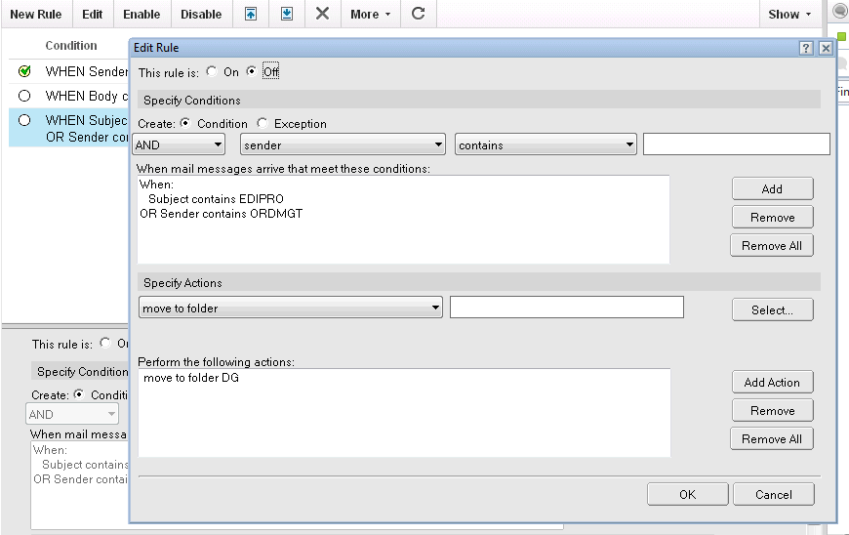

Once a rule is created it can be edited, enabled or disabled by going to More Mail Rules. Please note that rules marked with a green check (as in the image above) are enabled, and those without a green check are disabled.

- Sametime is the name for the Lotus Notes Instant Messaging function with which you can instant message with other associates. To access instant messaging settings go to Tools Sametime on the menu bar.
To see your Sametime Contacts list, click the chat icon ( ) on the right hand side of the Lotus Notes window.

To add someone to your Sametime Contacts list:

  - Right click on an email from them
  - Move the cursor over their name on the menu box that comes up
  - From the next menu that pops up, select “Add to Sametime Contacts List”
  - When prompted, select (or create) a group for the contact.
  - Click the “OK” button

If a person is available for chatting, a green square () appears by their name. If they have instant messaging turned on but are away from their desk, a yellow diamond () appears by their name.

To start a chat with someone, you can:

- Double click on their name in your Sametime Contacts list (if you added them)

- Right click on an email from them, move the cursor over their name on the popup menu box, and select “Chat” from the next menu that pops up

- Select an email from them and click the chat icon on the mailbox menu ( )

- To have your instant messaging status automatically change to unavailable when you have a meeting scheduled in your calendar:

  - On the menu bar, go to File Preferences
  - On the left hand menu, select Sametime Auto-Status Changes Calendar Service
  - Put a check in the “Check IBM Notes calendar for meetings to allow auto status changes” checkbox
  - Set the “Calendar refresh interval” value
  - Click the “Apply” button
  - On the left hand menu, click on the “Auto-Status Changes” section
  - Put a check in the “Meetings scheduled in my calendar” checkbox
  - Make sure the “Automatically change my status” and “Return to my previous state when the meeting is over” options are checked as well
  - Click the “Apply” button
  - Click the “OK” button

- To display related emails as a conversation rather than separate emails:

  - On the menu bar, select Actions Conversations

  - Open any email

  - Select Display Conversation from the email menu options

- A list of contacts can be imported from a .CSV file into Lotus Notes. To do this:

  - Layout the information in the .CSV file logically and include headers, such as:
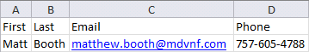
  - Go to your “Contacts” in Lotus Notes
  - On the menu bar, go to File Import Contacts
  - Browse to your .CSV file and select open
  - A new window will open showing the imported file information
  - Lotus Notes will try to assign the columns of the .CSV automatically
  - If the column assignment needs to be changed
    - Click the buton
    - In the new window, click and drag the column header from the box on the left to the desired Lotus Notes field in the box on the right

    - Click Apply
  - Click the “Import Button”
  - Click the “OK” button on the following popup box

- When working with an email history chain, it is possible to remove one of the collapsible previous emails without removing any of the other emails. To do this, right click on that email’s header box and select “Cut” from the popup menu box.

- Unfortunately, you cannot forward a Lotus Notes meeting invite to another associate and have them added to the meeting. Only the person who created the meeting invite can add additional people, so you will have to reach out to the meeting organizer if you would like another associate added to the meeting.

- You can setup Lotus Notes so that emails from particular senders in your mailbox will be highlighted or have their text color changed. To set this up:

  - On the menu bar, go to File Preferences
  - On the left hand menu, select “Mail”
  - Click on the “Sender Colors” tab
  - Click on the little arrow next to the ‘Sender names’ box to add the desired sender(s)
    - A “Select Names” popup box will be displayed
    - You can choose to search in your Contacts or the companywide Domino Directory

    - Type in a name to look for, starting with the last name

    - Click on the desired name in the left hand box and click the “Add” button to move the name into the right hand box

    - You can add multiple people at once
    - Click the “OK” button when done
  - Select the desired Background or Text color
  - Click the “OK” button
  - The changes will take effect the next time Lotus Notes is opened

- You can setup Lotus Notes to display a recipient icon next to your emails that will identify if you are the only person the email was sent to, if it was to only a few people or if it was sent to a whole bunch of people. This functionality makes it easier to prioritize your emails. To set this up:

  - On the menu bar, go to File Preferences
  - On the left hand menu, select “Mail”
  - Click on the “Recipient Icons” tab
  - Put a check in the following checkboxes, if desired:
    - “Mail sent to me only” – Will display a full blue circle
    - “Mail sent to no more than this number of recipients in the To field” – A half-filled circle will be displayed. Sent a desired number of recipients (5 is a good number to use)

    - “Mail sent to me as a cc / Mail is sent to more than 5 recipients in the To field” – A white circle will be displayed

  - Click the “OK” button

- In Outlook, it was possible to click on an email and print that email and all of its attachments at once. Unfortunately, Lotus Notes does not have this capability, so you have to print each attachment. One way to work around this is to save all the attachments to your computer at once and then print them all at once. To do this:

  - Go to the email in question
  - Print the email (Ctrl + P)
  - Right click on one of the attachments
  - Select “Save All”
  - Browse to or create a particular folder to save the attachments in
  - Click the “OK” button
  - Open Windows Explorer and go to the folder where the files were saved
  - Select all the files you wish to print
    - When selecting multiple files, they must be of the same type
  - Right click any of the selected files
  - Click on “Print” from the popup menu

- If you put a group in the address line of an email and would like to expand that group (such as to remove a particular individual from a secret birthday party), go to More Expand Public Groups on the email toolbar.

- If you are having a problem where email attachments you send are getting pushed to the bottom of an email chain, it is due to the internet mail format that Lotus Notes is using. You can change this setting with the following steps:

  - On the menu bar, go to File Preferences
  - On the left hand menu, select Mail Internet
  - For the “Internet mail format” setting, select the “HTML only” option from the drop down menu

  - Click the “OK” button
Please note that this will resolve the issue for emails you send out. If the email is later forwarded by someone who does not have an .html setting for internet mail, then the attachments may get pushed to the bottom of the email chain.

- If you like to change the number of lines that an email takes up in a folder or Inbox, then:

  - Open the folder in question
  - On the menu bar, go to View Customize This View
  - On the Entire View section, change the “Lines per row” setting to the desired number
  - Click the “OK” button
- When working in folders in Lotus Notes, you can change the default sort so that the newest emails appear at the top or bottom of the list. To change this setting:

  - On the menu bar, go to File Preferences
  - On the left hand menu, select “Mail”
  - Click on the “Basics” tab
  - Make sure the “Automatically sort date columns” checkbox has been checked
  - Select the desired option of “Most recent on top” or “Most recent on bottom”

  - Click the “OK” button

Please note that this change will affect all of your folders at once, including the inbox.

- If you would like to group emails in a folder by date such as yesterday, last week and last month (similar to Outlook), then:

  - Go the desired folder
  - Click the “Show” menu option in the upper right of the screen
  - Click on the “Group by Date” option
This change is made one folder at time.
- If you used the “Send and File” option to save a copy of an email that you sent in a folder or than “Sent”, the copy will automatically get deleted at 5 years rather than the 180 days that sent emails are automatically deleted.

- If you need to add or remove someone from an email group (a global group rather than a personal group), then:

  - Go to the Domino Directory
  - On the left hand menu, click on “Groups”
  - Find the name of the group in question
  - Click the option on the menu bar
  - Click on the “Administration” tab to verify who the “Administrator” is
  - If you are not the administrator, then:
    - Contact the administrator and ask them to add or remove the desired people
    - The administrator will then update the group
  - If you are the administrator, then:
    - Click on the small drop down arrow () at the end of the “Members” list
    - A “Select Names” popup box will be displayed
    - You can choose to search in your Contacts or the companywide Domino Directory

    - Type in a name to look for, starting with the last name

    - Click on the desired name in the left hand box and click the “Add” button to move the name into the right hand box

    - You can add multiple people at once
    - Click the “OK” button when done
  - Click to update the group

